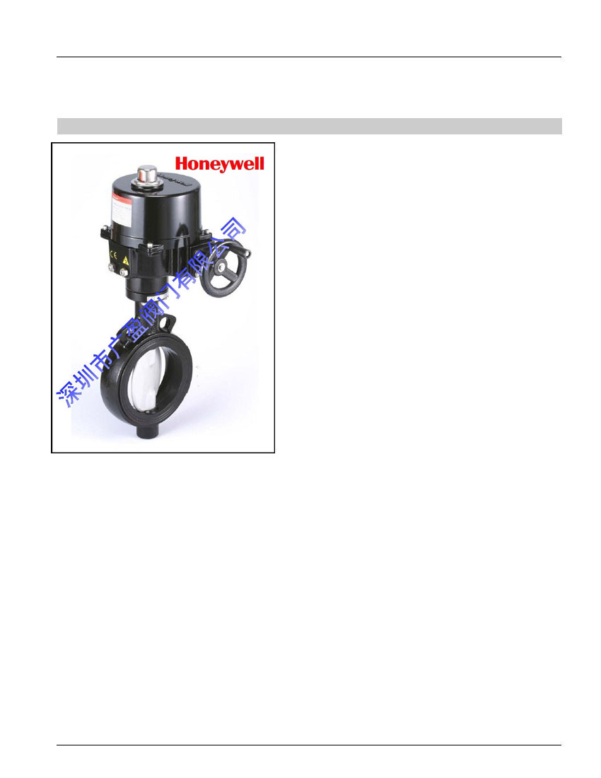
E
Honeywell
V4-ABFW-EPN16
ACTUATED WAFER TYPE BUTTERFLY VALVES
PRODUCT SPECIFICATION SHEET
FEATURES
•
•
•
•
•
•
•
•
•
•
Cast Iron Wafer Body
Centric butterfly valve with elastomer liner
Wide DN-range (DN 50 … DN600)
For On/Off or Modulating Control
Robust actuators in epoxy coated aluminum
Manual override non-clutch design. Manual operation can be
operated without any lever, clutch or brake upon power voltage.
Irreversible worm gear
Visual mechanical position indicator for accurate visual reference
of valve position
Anti-condensation heater and 2 aux. limit switches on standard
model
Enclosure IP67
SPECIFICATIONS
Valve
Sizes
Nominal pressure
Tightness
Temperature range
Body
Shaft
Disc
Liner
DN50 – DN600(Wafer Type)
PN16
Bubble tight
0-10 ~ 120 C Maximum
Cast Iron, BS EN1561 EN-JL1030
Stainless Steel, 970 416S21
Ductile Iron with epoxy coating
EPDM
GENERAL
The V4 Actuated Wafer Type Butterfly Valves are
suitable for heating and cooling applications. They can
also be employed for industrial applications, general
services and water treatment.
The V4 series is equipped with standard On/Off or
modulating (4~20mA, 1~5V, or 0(2)~10V select by
DIP-switch) control quarter-turn electric actuator.
Actuator
Motor Voltage
Current, Running time
Travel Angle
Input (Modulating)
Enclosure
Ambient Temperature
Indicator
Manual Override
Worm Gear
Mechanical Stops
Space heater
Material
External Coating
Stall Protection
230VAC, 50 / 60 Hz
See table (1)
oo90 ± 5
4~20mA, 1~5V, or 0(2)~10V select by DIP-
switch
IP67 Watertight
-5 °C to +60 °C
Continuous Position Indicator
Non-clutch design
Permanently lubricated and self locking
External Adjustable Limit stops
15W 230V Anti-condensation
Steel. Aluminium Alloy, Al Bronze
Anodized and dry powder epoxy
Built-in thermal protection
Cut off at 125 ± 5 °C
Reset at 95 ± 5 °C
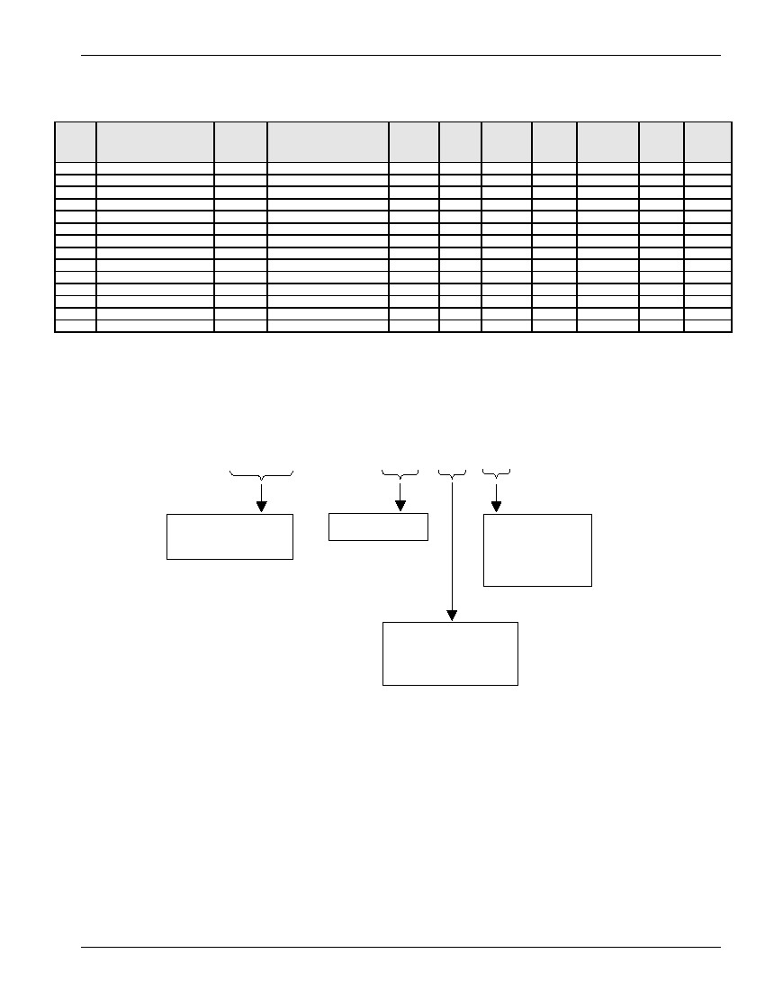
V4-ABFW-EPN16 ACTUATED BUTTERFLY VALVE
Table (1) Control Type and Valve Size Data
The below table is based on differential pressure of 10 bar.
Valve
Size
DN50
DN65
DN80
DN100
DN125
DN150
DN200
DN250
DN300
DN350
DN400
DN450
DN500
DN600
On/Off
Model No.
V4-ABFW-EPN16-050-03
V4-ABFW-EPN16-065-03
V4-ABFW-EPN16-080-03
V4-ABFW-EPN16-100-03
V4-ABFW-EPN16-125-03
V4-ABFW-EPN16-150-03
V4-ABFW-EPN16-200-03
V4-ABFW-EPN16-250-03
V4-ABFW-EPN16-300-03
V4-ABFW-EPN16-350-03
V4-ABFW-EPN16-400-03
V4-ABFW-EPN16-450-03
V4-ABFW-EPN16-500-03
V4-ABFW-EPN16-600-03
Actuator
Type
OM-1
OM-1
OM-2
OM-2
OM-2
OM-3
OM-3
OM-4
OM-5
OM-7
OM-8
OM-8
OM-9
OM-11
Modulating
Model No.
V4-ABFW-EPN16-050-04
V4-ABFW-EPN16-065-04
V4-ABFW-EPN16-080-04
V4-ABFW-EPN16-100-04
V4-ABFW-EPN16-125-04
V4-ABFW-EPN16-150-04
V4-ABFW-EPN16-200-04
V4-ABFW-EPN16-250-04
V4-ABFW-EPN16-300-04
V4-ABFW-EPN16-350-04
V4-ABFW-EPN16-400-04
V4-ABFW-EPN16-450-04
V4-ABFW-EPN16-500-04
V4-ABFW-EPN16-600-04
Max Op Time
ActuatorPower
Torque sec/90°
Type(Watts)
(Nm) at 60Hz
OM-P1
OM-P1
OM-P2
OM-P2
OM-P2
OM-P3
OM-P3
OM-P4
OM-P5
OM-P7
OM-P8
OM-P8
OM-P9
OM-P11
35
35
35
90
90
150
150
400
500
1000
1500
1500
2000
3000
12
12
12
15
15
22
22
22
22
46
46
46
58
58
10
10
10
40
40
40
40
120
120
180
220
220
220
250
Manual
Override
Lever
Lever
Lever
Hand-wheel
Hand-wheel
Hand-wheel
Hand-wheel
Hand-wheel
Hand-wheel
Hand-wheel
Hand-wheel
Hand-wheel
Hand-wheel
Hand-wheel
Kvs
(m3/h)
100
170
281
619
884
1366
2713
4819
7136
10485
14007
18560
23860
36900
Weight
Kg
13.4
14.4
14.6
16.6
20.1
25.0
29.9
43.4
55.8
89.0
145.0
165.0
184.0
241.0
Figure (1) Product Identification System
The labeling system for Honeywell butterfly valves is as follows:
V4 – ABFW – EP16 – 050 – 03 -
ABFW – Wafer body
ABFL – Lug body
Valve Size in mm
Disc Material
– Ductile iron
1 – Stainless steel
2 - AluBronze
Control Type
03 – On/Off control
04 – Modulating control

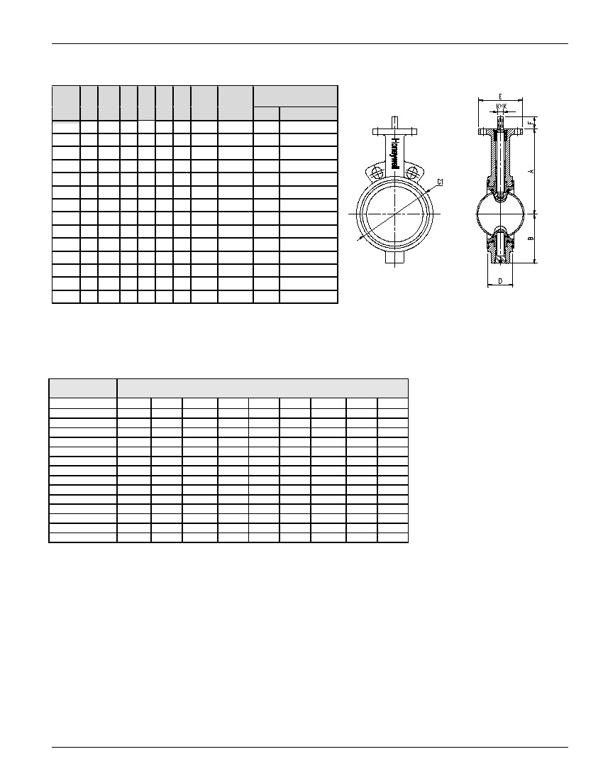
V4-ABFW-EPN16 ACTUATED BUTTERFLY VALVE
Table (2) Valve Dimensions and Weight
Size
A
B
C1
D
E
F
KxK Weight
(Kg)
4.5
5.4
5.6
7.6
10.1
12.0
16.9
26.4
37.8
67
110
127
160
185
Top Plate Date
PCD HOLE N-Dia.
DN50
DN65
DN80
DN100
DN125
DN150
DN200
DN250
DN300
DN350
DN400
DN450
DN500
DN600
140
152
159
70
76
88
105 41
117 44
130 44
90
90
90
90
90
90
30 11x11
30 11x11
30 11x11
30 14x14
30 14x14
30 17x17
70
70
70
70
70
70
102
102
102
125
140
140
140
165
4 - Ø9
4 - Ø9
4 - Ø9
4 - Ø9
4 - Ø9
4 - Ø9
4 - Ø11
4 - Ø11
4 - Ø11
4 - Ø14
4 - Ø18
4 - Ø18
4 - Ø18
4 – Ø22
178 102 162 51
191 119 187 54
203 133 216 54
241 170 271 64 125 45 17x17
273 210 330 64 125 45 22x22
311 238 376 76 125 45 22x22
368 267 436 80 150 45 22x22
400 309 488 90 175 45 27X27
422 318 535 109 175 45 27X27
480 350 585 127 175 45 36X36
562 410 685 154 210 45 36X36
Table (3) Hydraulic Characteristics
The below table shows the Kv – values at different opening angles:
Nominal Size
10o
DN50
DN65
DN80
DN100
DN125
DN150
DN200
DN250
DN300
DN350
DN400
DN450
DN500
DN600
0.05
0.09
0.17
0.26
0.43
0.69
1.70
2.60
3.50
5.1
6.8
9.4
11.9
18.8
Kv – value at Disk Opening Angle
20o
2.60
5.20
7.80
15
25
39
77
131
202
289
397
526
676
1044
30o
6.10
10
16
31
53
82
163
277
428
611
840
1113
1431
2211
40o
13
22
34
68
115
177
353
600
927
1324
1821
2412
3101
4791
50o
23
39
61
120
205
317
629
1070
1653
2360
3245
4297
5526
8538
60o
38
65
100
199
339
523
1040
1771
2735
3904
53639
7111
9144
14126
70o
61
103
158
315
536
829
1646
2803
4329
6179
8497
11255
14471
22356
80o
91
154
238
472
804
1243
2469
4205
6494
9268
12746
16882
21706
33535
90o
100
170
261
519
884
1366
2713
4619
7136
10185
14007
18551
23853
36851

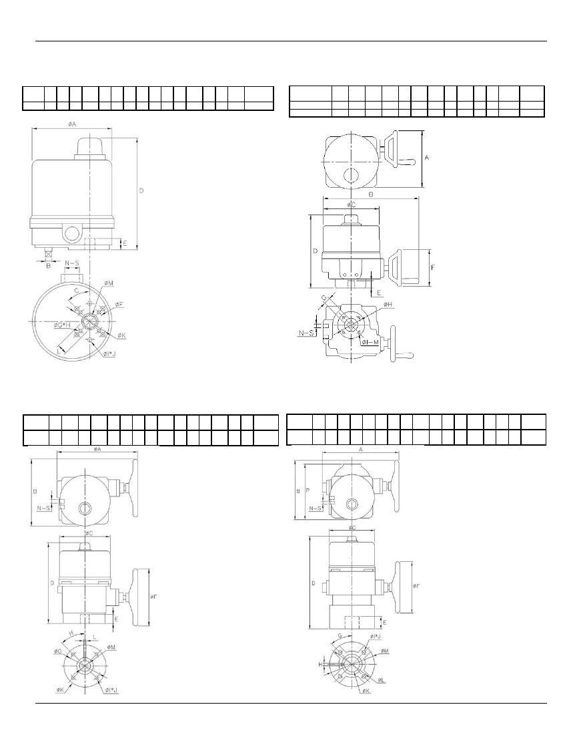
V4-ABFW-EPN16 ACTUATED BUTTERFLY VALVE
Table (4a) Actuator Dimensions
(OM-1)
Model A B CDEFGHIJ
No.
OM-1 108 8 45° 155 15 36 m5 4 m6 6
LM
max
50 14 19
K
N
Flange
Type
1 ½ PT F03/F05
S
Table (4b) Actuator Dimensions
(OM-2 to OM-3, OM-4 to OM-6)
GHIM
Max
OM-2 to OM-3 200 300 200 255 30 125 22 70 m8 4
OM-4 to OM-6 300 380 234 315 40 195 35 102 m10 4
Model No.
A
B
C
D
E
F
N
2
2
Flange
Type
½ PT F07
½ PT F10
S
Option: (1) L = 11, M = 15
(2) L = 9, M = 12
With modulating card, D = 185
Table (4c) Actuator Dimensions
(OM-7 to OM-8)
Model ABCDEFGHIJKLM N S Flange
No.maxType
OM-7 to 450 340 234 420 60 295 140 45° m16 4 180 10 35 2 ½F14
OM-8PT
Table (4d) Actuator Dimensions
(OM-9 to OM-12)
Model A B C D E F G HIJ
No.
OM-9 to 470 350 260 590 100 395 45° 12 m20 4
OM-12
K
L
M
P
N
S Flange
Type
½ F16/F14
PT
75 165 221 360 2
Note:
without torque switch A = 385


V4-ABFW-EPN16 ACTUATED BUTTERFLY VALVE
INSTALLATION
WARNING!
Remove power before the cover is
dismantled!
The actuator must be handled with the
utmost care when the cover is removed
and the power connected!
ELECTRIC WIRING
Note:
Electric wiring must be carried out by
qualified personnel only!
Wiring diagram is also shown on the label of
top cover.
Loosen the screws on the cover and lift it off.
Check the voltage marked on the actuator label.
MOUNTING ON VALVE
Operate the valve manually to fully open or fully closed
position before the actuator is mounted.
Operate the actuator and valve stem to fully open or
fully closed position.
Check that the actuator and valve stem are in correct
position. Please note, valve and actuator must be in
the same mode (fully open/fully closed) prior to the
assembly.
Mount the actuator on the valve and check that the
actuator and valve stems are centered and aligned.
Operate the valve manually with the aid of the actuator
hand-wheel and check that the valve moves with
normal resistance.
Check that all screws are correctly tightened.
Connect according to the enclosed wiring diagram or if
the actuator is of standard design, according to the wiring
diagram below. The wiring diagram is drawn in unaffected
position (the valve in the intermediate position).
Test run the actuator from intermediate position checking
that the actuator turns in the correct direction.
Test run the actuator and check that the limit switches
work correctly.
Check that the cable entries and possible blind plug are
sealed.
Mount the cover.

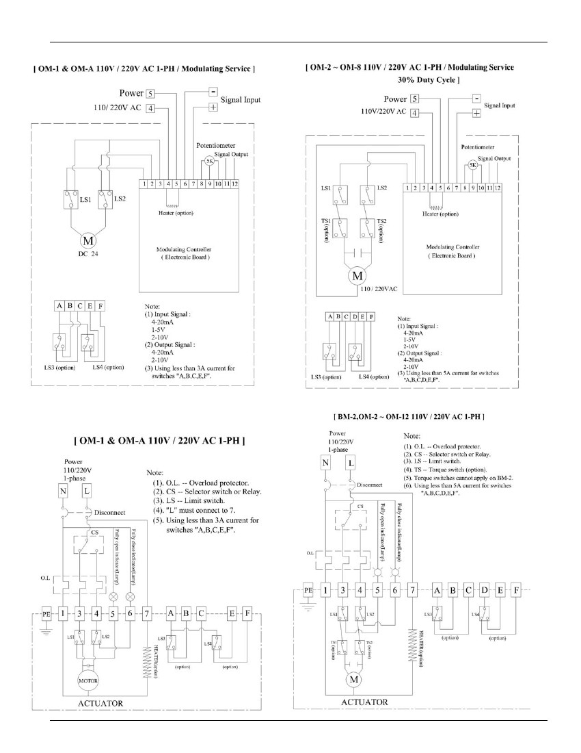
V4-ABFW-EPN16 ACTUATED BUTTERFLY VALVE
WIRING DIAGRAM FOR MODULATING
WIRING DIAGRAM FOR ON/OFF

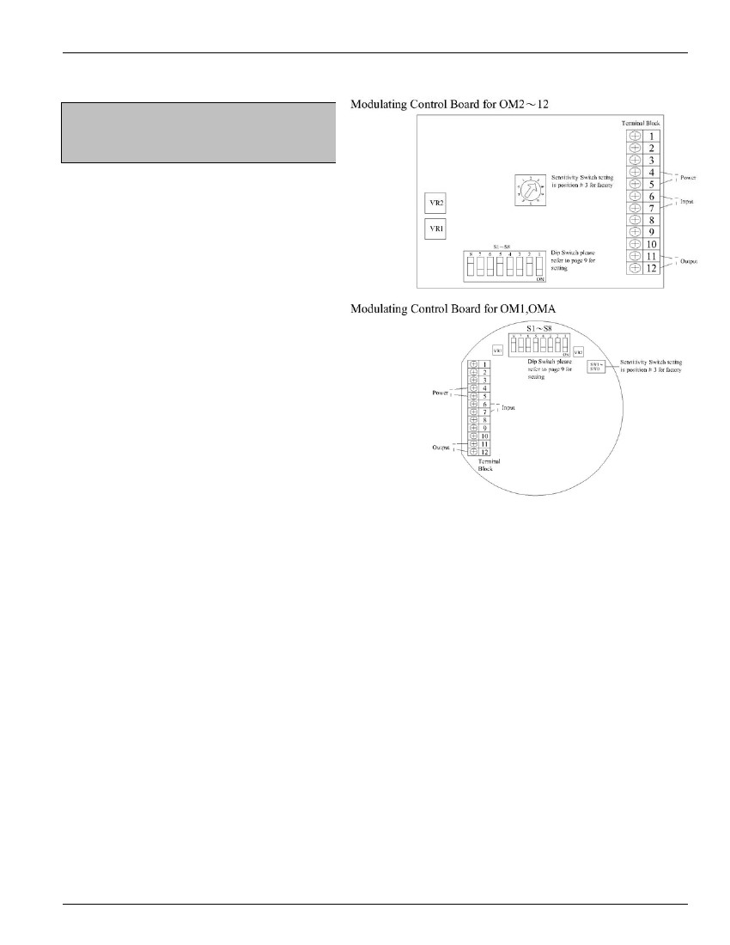
V4-ABFW-EPN16 ACTUATED BUTTERFLY VALVE
FUNCTION SETTING
Note:
Turn the power off before changing the following
setting.
S1~S8: Function setting by DIP switches
S1, S2: DIP switches for input signal select
“4~20mA” set 1-ON / 2-OFF.
“1~5V” set 1-OFF / 2-OFF.
“2~10V” set 1-OFF / 2-ON.
S3, S4, S5: DIP switches for feedback signal select
“2~10V” set 3-ON / 4-OFF / 5-ON.
“4~20mA” set 3-OFF / 4-ON / 5-OFF.
S6: DIP switch for direct/reverse action
Valve is fully-open when the input signal is 4mA, 2V or 1V
and valve is fully-closed when the input signal is 20mA, 10V
or 5V, set 6-ON.
Valve is fully-closed when the input signal is 4mA, 2V or 1V
and valve is fully-open when the input signal is 20mA, 10V or
5V, set 6-OFF.
S7, S8: DIP switches for valve position when input signal fails
“valve fully-closed” set 7-OFF / 8-ON.
“valve fully-open” set 7-ON / 8-OFF.
“valve stops” set 7-ON / 8-ON.
SW1~0 (10 steps): Sensitivity adjustable switch
When switch to “1”, the 0~90 degree can be divided up to
around 80 times movement.
When switch to “0”, the 0~90 degree can be divided up to
around 17 times movement.
The sensitivity decreases 7 times movement by sectors from
SW1 to SW2, SW2 to SW3, SW3 to SW4 and so on.

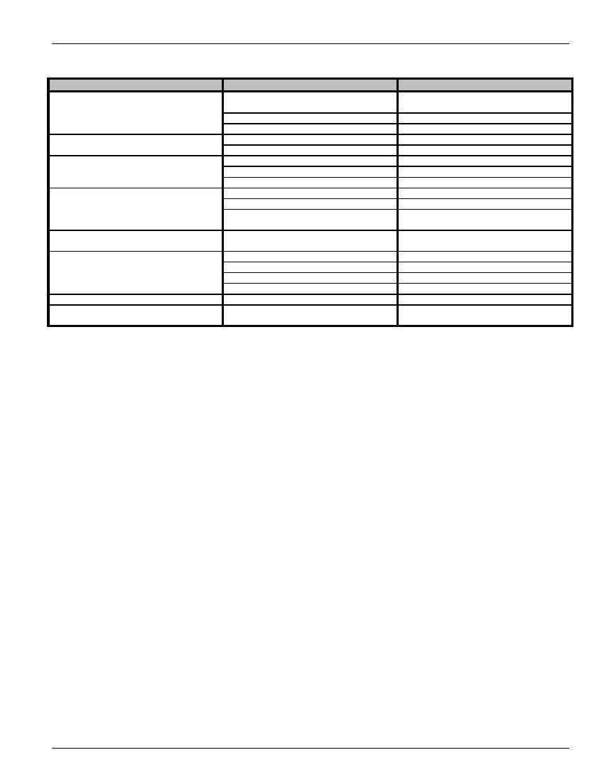
V4-ABFW-EPN16 ACTUATED BUTTERFLY VALVE
TROUBLE SHOOTING
Conditions
Motor does not operate
Possibilities
1. Is the supplied power and voltage
correct?
2. Any blisters on the capacitor?
3. Are the gear train free?
1. Is the power supply short circuited?
2. Any foreign objects in flow stream?
1. Loose/Misalign cam?
2. Bent valve stem?
3. Mechanical stop adjustment incorrect?
1. Gear worn out?
2. Sleeve adapter worn out or broken?
3. Broken valve stem or actuator
transmission shaft?
Controlling circuit connects in tandem or
parallel.
1. Is the voltage correct?
2. Is valve too tight to operate?
3. High duty working frequency?
4. Is motor stem bearing or blinding?
Simultaneous input power on/off.
Motor brake spring fatigued or Teflon
worn?
Solution
1. Check by meter.
2. If so, replace.
3. Remove motor and check.
1. Check wiring.
2. Check for obstructions.
1. Adjust/Tighten using spanner.
2. Replace valve stem.
3. Check position of stops.
1. Replace gear.
2. Replace sleeve adapter.
3. Replace valve stem or actuator
transmission shaft.
Refer to the wiring diagram.
1. Check by meter.
2. Replace valve.
3. Check duty cycle.
4. Replace the blinding parts.
Check if the selectable switch is normal.
Replace spring or Teflon.
Motor stops running
Unable to fully open/close
Valve stops operating when motor is
running.
Abnormal control for operating two or
more actuators simultaneously.
Motor overheats
Occasional on/off actuator failure.
Vibration when valve is closed.

